www.totolink.net
www.totolink.net

How to set parental control function on TOTOLINK router
It is suitable for ：X6000R，X5000R,X60,X30,X18,T8,T6,A3300R,A720R,N350RT,N200RE_V5,NR1800X,LR1200W（B）,LR350

Background Introduction：
Controlling the online time of children at home has always been a concern for many parents. TOTOTOLINK's parental control function perfectly solves parents' worries.
Set up steps
STEP 1: Log in to the wireless router management page
In the browser address bar, enter: itoolink.net. Press the Enter key, and if there is a login password, enter the router management interface login password and click "Login".
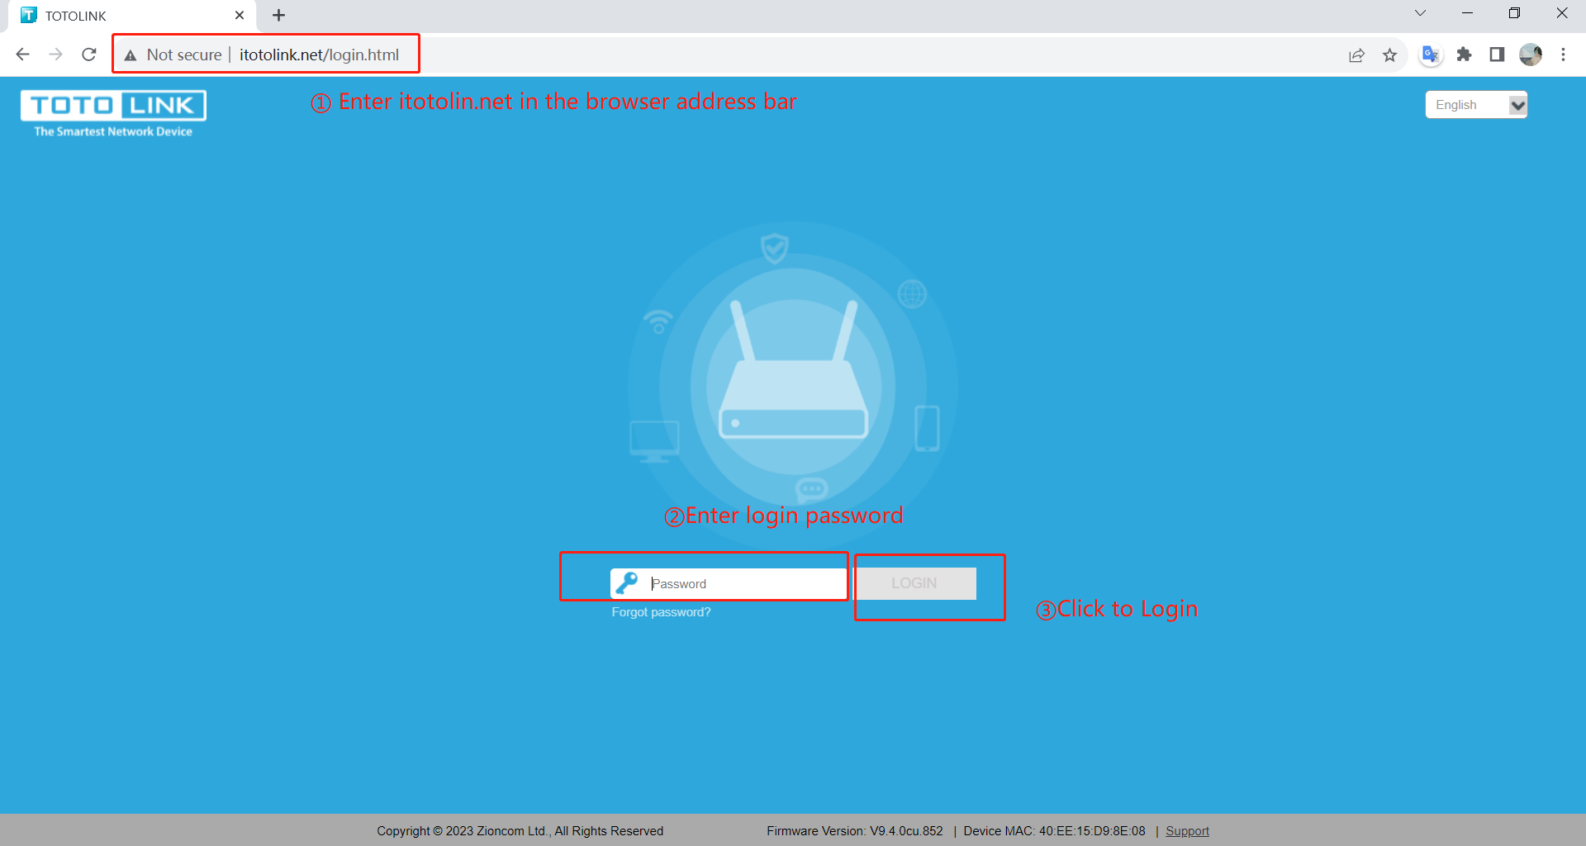

STEP 2 :
Select Advanced ->Parental Controls, and open the "Parental Controls" function
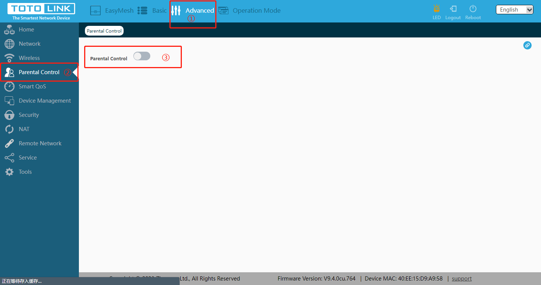

STEP 3 :
Add new rules, scan all device MACs connected to the router, and select the devices that need to be added with control
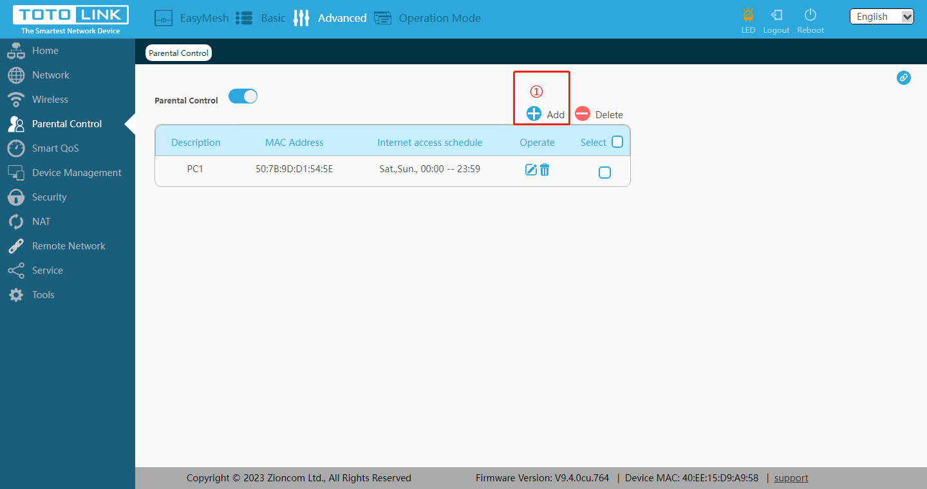
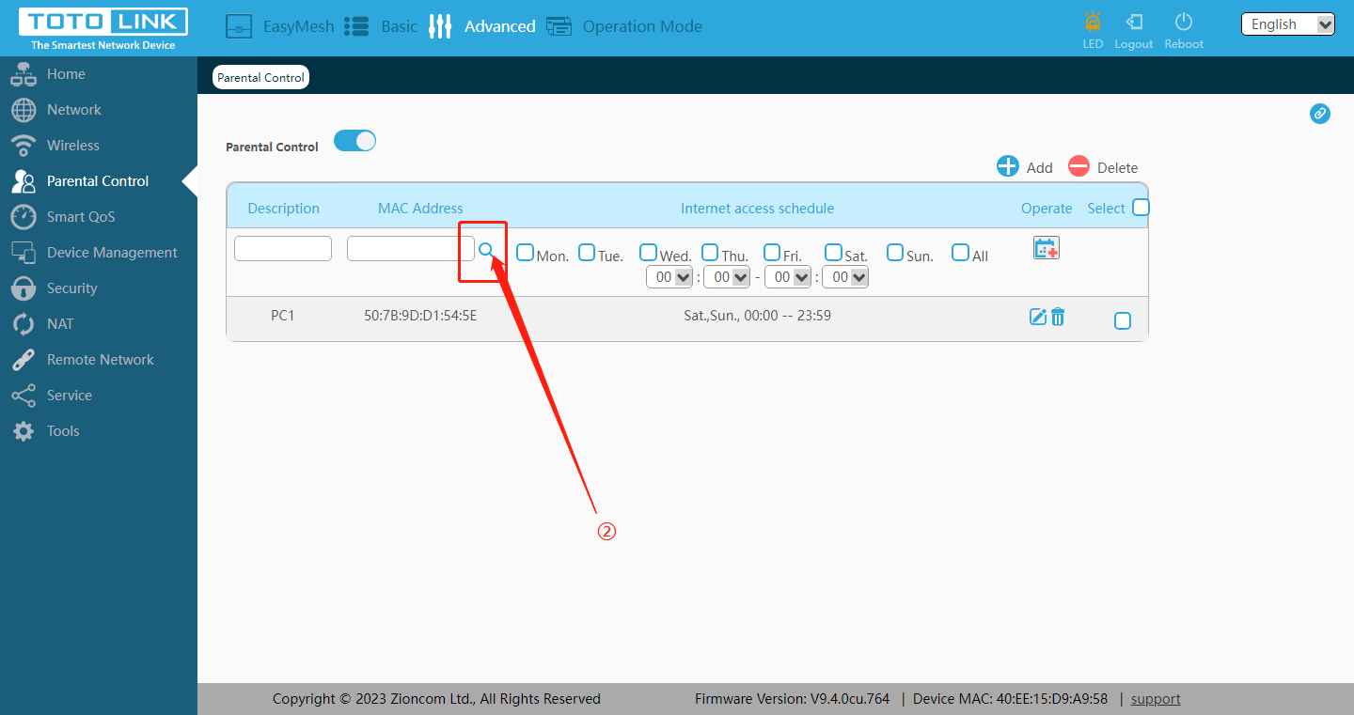
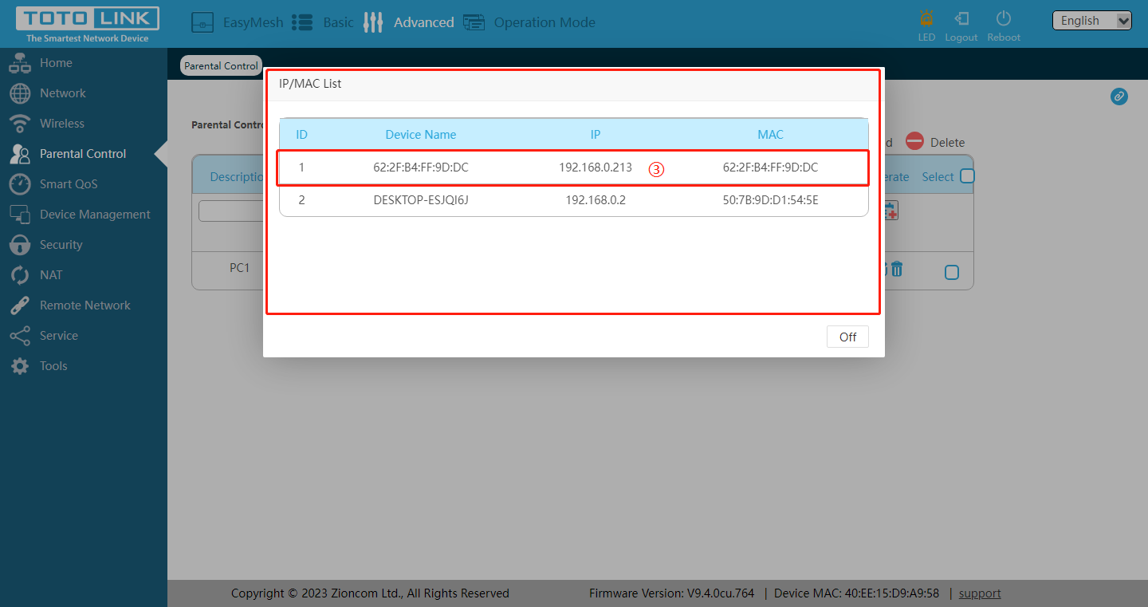

STEP 4 :
Set the time period for allowing internet access, and add it to the rules after completing the setting.
The following figure shows that devices with MAC 62:2F: B4: FF: 9D: DC can only access the internet from 18:00 to 21:00 from Monday to Friday
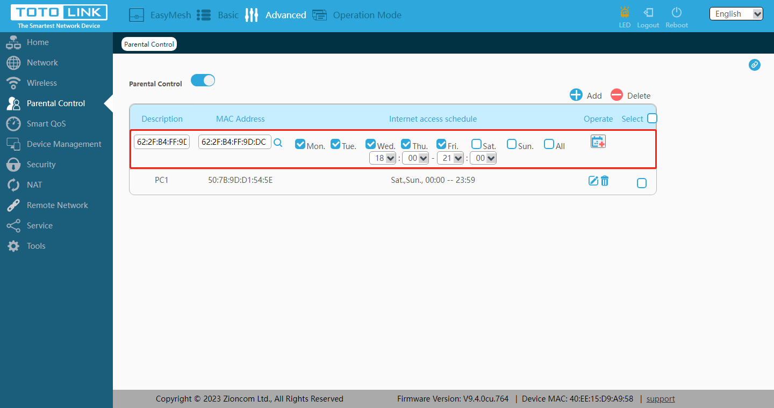

STEP 5:
At this point, the parental control function has been set up, and the corresponding devices can only access the network within the corresponding time range

Note: To use the parental control function, select the time zone in your region
